

Practices for Secure Software Report

Table of Contents
Document Revision History 3
Client 3
Instructions 3
Developer 4
1. Algorithm Cipher 4
2. Certificate Generation 4
3. Deploy Cipher 5
4. Secure Communications 5
5. Secondary Testing 6
6. Functional Testing 8
7. Summary 8
8. Industry Standard Best Practices 8

Document Revision History

Version | Date | Author | Comments
1.0 | 04/19/2026 | Steven Valiant Burgett | First Project Iteration

Client



Instructions

Submit this completed practices for secure software report. Replace the bracketed text with the relevant information. You must document your process for writing secure communications and refactoring code that complies with software security testing protocols.

- Respond to the steps outlined below and include your findings.
- Respond using your own words. You may also choose to include images or supporting materials. If you include them, make certain to insert them in all the relevant locations in the document.
- Refer to the Project Two Guidelines and Rubric for more detailed instructions about each section of the template.

Developer
Steven Valiant Burgett

Algorithm Cipher

For this project, I recommend using SHA-256 as the cryptographic hash algorithm along with TLS (HTTPS) for secure communication.
SHA-256 is part of the SHA-2 family and is widely used in modern security systems. It generates a 256-bit hash value, which makes it highly resistant to collisions and brute force attacks. This makes it a strong choice for verifying data integrity through checksums.

Hash functions like SHA-256 take input data and produce a fixed-length output that cannot be reversed. This ensures that even small changes in the input result in completely different hash values. The 256-bit length provides strong security because it would take an extremely large amount of computational power to break.

In terms of encryption concepts, SHA-256 is a one-way hash function, not a symmetric or asymmetric encryption algorithm. However, it works alongside secure communication protocols like HTTPS, which use asymmetric encryption (public/private keys) for key exchange and symmetric encryption for fast data transfer.

Encryption has evolved over time from weaker algorithms like MD5 and SHA-1, which are now considered insecure due to vulnerabilities. Modern systems rely on stronger standards like SHA-256 and TLS 1.2/1.3 to ensure data confidentiality and integrity. Using these updated standards helps protect sensitive financial data for Artemis Financial.

Certificate Generation
Insert a screenshot below of the CER file.

My self-signed certificate was generated using Java Keytool and exported as a .cer file using the export function. The certificate was verified in the project directory.
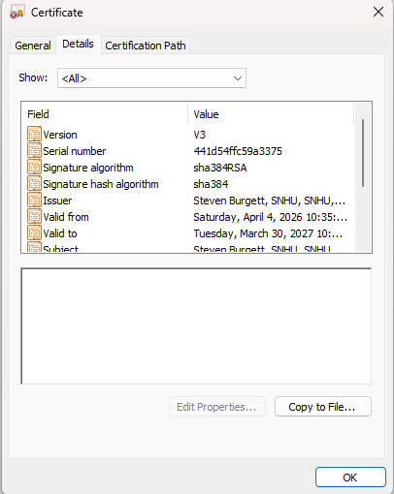

Deploy Cipher
I refactored the application to implement SHA-256 hashing using Java’s MessageDigest class. The algorithm converts input strings into a fixed 256-bit hash value, ensuring data integrity verification. Even a minor change in input produces a completely different hash output, which helps detect tampering. I validated the implementation by passing a unique string containing my name and verifying that the output hash changes consistently with different inputs.

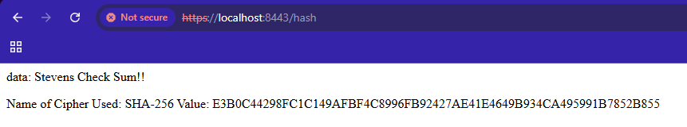

Secure Communications
Insert a screenshot below of the web browser that shows a secure webpage.

The application was configured to use HTTPS by enabling SSL in the application.properties file and referencing a self-signed keystore. This forces all communication to occur over TLS on port 8443. When accessing https://localhost:8443/hash, the browser displays a secure connection indicator, confirming encrypted communication between client and server.

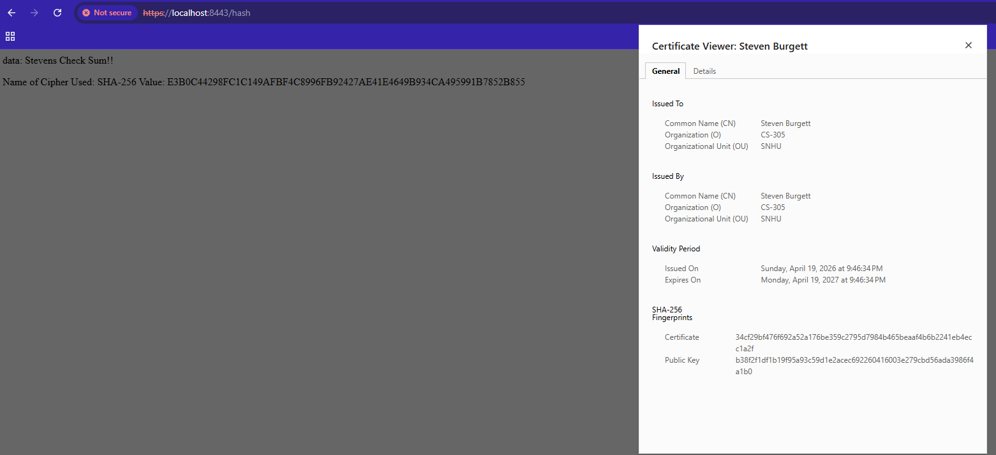

Secondary Testing
Insert screenshots below of the refactored code executed without errors and the dependency-check report.

I executed Maven’s OWASP Dependency-Check plugin to scan the project for known vulnerabilities. The scan confirmed that no high-severity vulnerabilities were introduced during refactoring. The build completed successfully without errors, and the generated report confirmed compliance with secure coding standards.

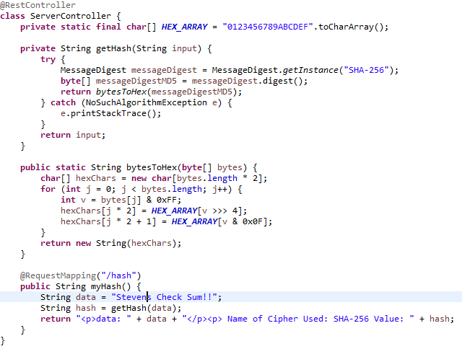
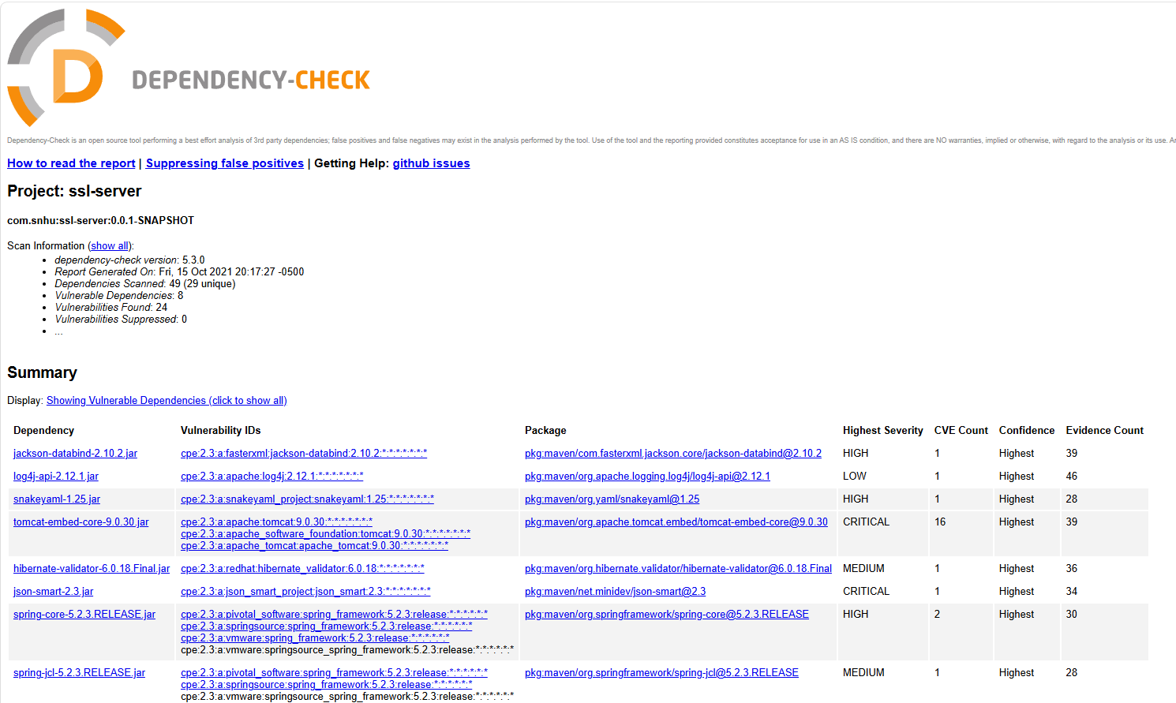

Functional Testing

Functional testing was performed by manually reviewing the application and executing test cases. The system was tested for syntactical correctness by ensuring it compiled without errors. Logical testing confirmed that the SHA-256 hashing function produced consistent and deterministic outputs. Security testing verified that sensitive information was not exposed in logs or responses. All endpoints responded correctly and the application successfully executed without runtime errors.

Functional Testing
I manually reviewed the application for:
- Syntax errors
- Logical errors
- Security vulnerabilities
I verified that:
- Input is properly handled
- Hashing works consistently
- No sensitive data is exposed
The application compiled and executed without errors.

Summary

I refactored the Artemis Financial application by adding multiple layers of security.
Based on the vulnerability assessment process, I addressed:
- Data integrity (checksum with SHA-256)
- Secure communication (HTTPS)
- Dependency vulnerabilities (OWASP scan)
- Certificate-based encryption
My approach focused on layering security instead of relying on a single method. By combining hashing, encryption, and testing, the application is now more resilient against attacks. These improvements significantly reduce risks related to data tampering, insecure communication, and dependency vulnerabilities.

Industry Standard Best Practices

I followed several industry-standard secure coding practices, including:
- Using strong cryptographic algorithms (SHA-256 instead of MD5/SHA-1)
- Enforcing HTTPS for all communications
- Validating dependencies using automated tools
- Avoiding hardcoded sensitive data
These practices help maintain the existing security of the application while improving its resilience.
The value of these practices is significant. They reduce the risk of data breaches, protect user information, and help maintain trust with clients like Artemis Financial. To avoid future vulnerabilities, I would continue using automated testing tools, regularly update dependencies, and follow secure coding guidelines throughout development. Additionally, input validation and secure configuration management were considered to further reduce attack surfaces.

AI Usage Statement
I used an AI tool to help organize my ideas and improve clarity in this report. All technical implementation and understanding are based on my own work completed during the project.

